PREDICTIVE LOGISTICS AND DELIVERY
PERFORMANCE OPTIMIZATION USING PYTHON
Final Project Report
Logistics Data Analytics Project
Submitted by:
PRIYA M JADHAV
USN: 4AL24CS151
Department of Computer Science and Engineering
Alvas Institute of Engineering and Technology
Academic Year 2026–2027

Abstract
This project develops a data-driven approach for logistics and delivery performance analysis using Python. The analysis uses a cleaned public supply-chain dataset containing 180,519 shipment/order records and 54 columns after preprocessing. The project examines actual and scheduled shipping time, delivery delay, delivery performance, shipping mode, regions, order information, and product-related variables. Exploratory data analysis and KPI analysis are used to understand operational patterns, while regression and clustering are applied as data-science methodologies for delivery-time prediction and shipment segmentation. The observed average actual shipping time is 3.50 days compared with an average scheduled time of 2.93 days, producing an average delay of 0.57 days. 103,400 records are classified as delayed and 77,119 as on time. A Linear Regression model using scheduled shipping time, order quantity, and product price achieved an MAE of 1.13 days and an R² of 0.270 on the held-out test set. K-Means clustering produced three shipment segments. The project concludes with practical recommendations for monitoring delays, prioritizing shipments, allocating resources, and using predicted delivery time to support logistics planning.

Table of Contents
- 1. Introduction
- 2. Problem Statement
- 3. Project Objectives and Scope
- 4. Logistics Scenario
- 5. Dataset and Data Sources
- 6. Data Cleaning and Preprocessing
- 7. Exploratory Data Analysis
- 8. KPI Analysis and Results
- 9. Data Science Methodologies
- 10. Strategic Roadmap
- 11. Business Insights and Recommendations
- 12. Limitations
- 13. Future Scope
- 14. Conclusion
- 15. References
- Appendix A – Python Code Illustrations

1. Introduction
Logistics operations involve the movement of products from order placement through shipment and delivery. Delivery performance is affected by transportation mode, scheduled delivery requirements, order characteristics, product characteristics, and regional operating conditions. A data analytics approach can convert historical shipment records into measurable performance indicators and actionable insights.
This project, Predictive Logistics and Delivery Performance Optimization Using Python, uses Python-based data analysis to examine shipment performance, identify delivery delays, calculate logistics KPIs, explore regional and transportation patterns, and demonstrate predictive and segmentation techniques.
The project is framed around LogiTrack Logistics Pvt. Ltd., a fictional logistics organization operating shipments across multiple regions in India and facing delivery delays and resource-allocation challenges.

2. Problem Statement
LogiTrack Logistics Pvt. Ltd. needs a structured way to understand why delivery performance varies, where delays are concentrated, and how historical shipment information can support better planning. The project addresses the problem by cleaning logistics data, measuring delivery performance, identifying patterns through exploratory analysis, and applying regression and clustering techniques.
Research question: How can data science techniques be used to analyze logistics data, predict delivery performance, identify potential delays, and support efficient transportation resource allocation?

3. Project Objectives and Scope
- Analyze historical logistics and delivery data using Python.
- Identify factors associated with delivery time and delays.
- Measure logistics performance using relevant KPIs.
- Compare delivery performance across transportation modes and regions.
- Use visualization to identify patterns and trends.
- Apply regression to demonstrate delivery-time prediction.
- Apply clustering to segment similar shipments.
- Develop practical strategies for transportation and resource allocation.
Scope includes shipment/delivery performance analysis, delay analysis, KPI measurement, exploratory visualization, regression, clustering, and optimization strategy planning. The project does not claim to estimate profit margin, customer-level behavior, inventory sell-through, campaign ROI, or target-versus-actual performance where the dataset does not provide the required information.

4. Logistics Scenario
LogiTrack Logistics Pvt. Ltd. manages a large volume of shipments. Management wants a single analytical view of delivery performance because manual spreadsheets make it difficult to compare regions, transportation modes, and shipment characteristics. The project therefore treats historical shipment records as the foundation for operational monitoring and predictive planning.
The proposed business goal is to reduce delivery delays, improve on-time performance, and allocate transportation resources more effectively. Proposed planning targets from the Week 1 specification are an on-time delivery rate of at least 90%, a 10% reduction in average delivery time, a 15% reduction in average delay, fulfillment of at least 95%, and cancellation below 5%.

5. Dataset and Data Sources
The project uses the DataCo Smart Supply Chain dataset supplied with the project package. The raw dataset was placed in the project's 02_Data/raw folder and processed into a cleaned CSV. The cleaned dataset contains 180,519 rows and 54 columns.
Important fields include Days for shipping (real), Days for shipment (scheduled), Delivery Status, Late_delivery_risk, Order Date, Shipping Date, Order Region, Order Status, Shipping Mode, Order Item Quantity, Order Item Product Price, Sales, Order Item Total, and other order/product attributes.
Dataset characteristic | Value
Cleaned records | 180,519
Cleaned columns | 54
Actual shipping time (mean) | 3.50 days
Scheduled shipping time (mean) | 2.93 days
Average delivery delay | 0.57 days
Delayed records | 103,400
On-time records | 77,119
Delayed-record rate | 57.28%
On-time rate | 42.72%

6. Data Cleaning and Preprocessing
The preprocessing workflow loads the raw CSV using Pandas, checks duplicates and missing values, removes completely empty columns, converts date fields, converts selected numeric fields to numeric types, and derives delivery delay from actual versus scheduled shipping days.
The derived variable "Delivery Delay" is calculated as actual shipping days minus scheduled shipping days. A "Delivery Performance" field classifies records with delay less than or equal to zero as "On Time" and records with positive delay as "Delayed". The cleaned dataset was saved as 02_Data/processed/cleaned_logistics_data.csv.
- Final dataset size after preprocessing: 180,519 rows × 54 columns.
- Derived delivery delay and delivery-performance indicators.
- Prepared the data for EDA, KPI analysis, regression, and clustering.

7. Exploratory Data Analysis
Exploratory analysis examined shipping-mode distribution, delivery performance, delivery-delay distribution, actual shipping days, top order regions, and average shipping time by transportation mode. The project generated visualizations in the 05_Visualizations folder.
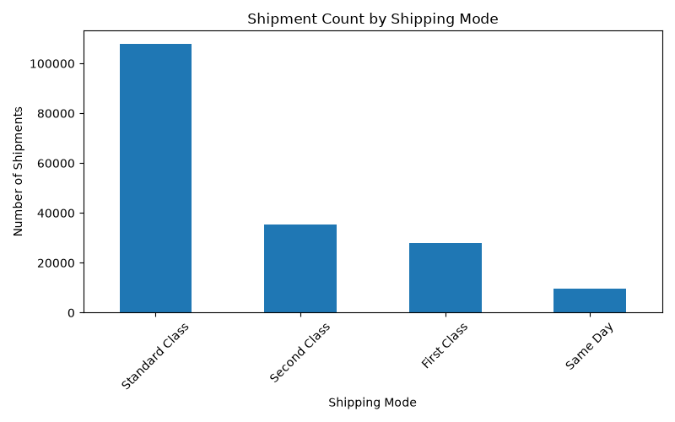
Figure 1. Shipping mode distribution
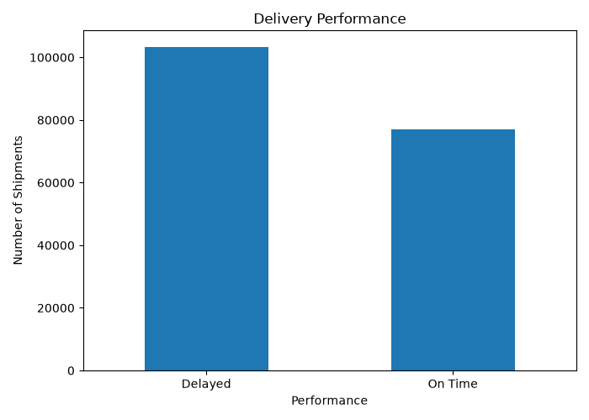
Figure 2. Delivery performance
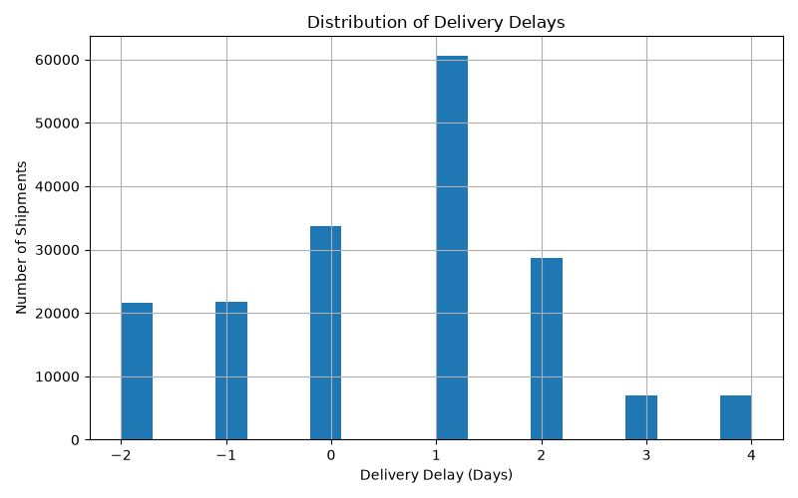
Figure 3. Delivery delay distribution
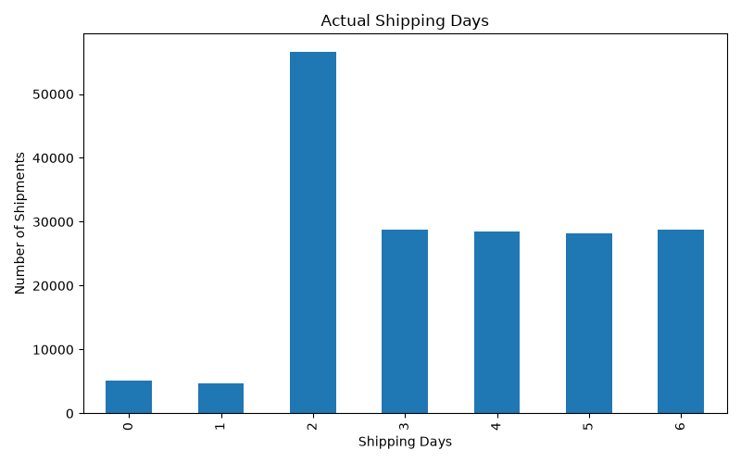
Figure 4. Actual shipping days
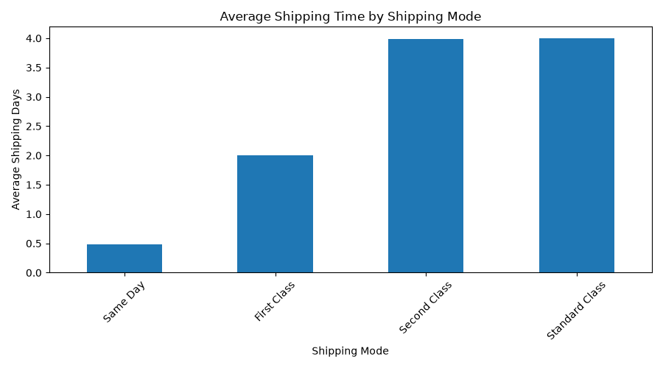
Figure 5. Average actual shipping time by shipping mode
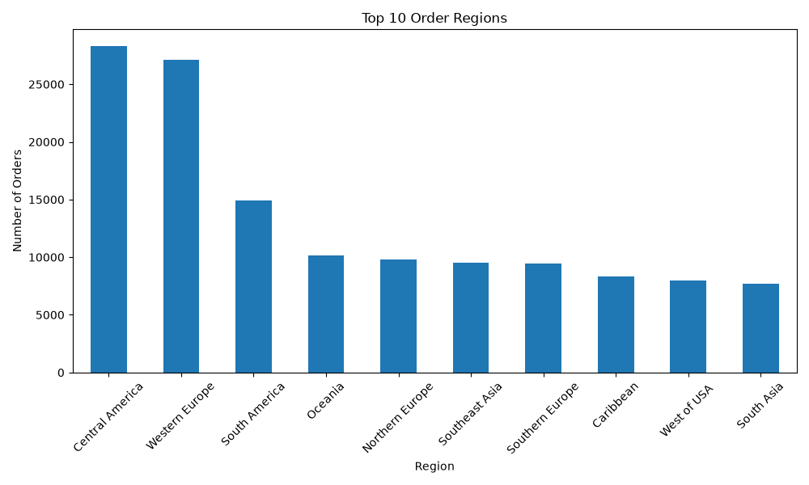
Figure 6. Top order regions

8. KPI Analysis and Results
The KPI analysis measures actual shipping time, scheduled shipping time, delivery delay, and delivery performance. The results below are calculated directly from the cleaned project dataset.
KPI | Observed result | Interpretation
On-Time Delivery Rate | 42.72% | Share of records classified as On Time.
Delayed-record Rate | 57.28% | Share of records classified as Delayed.
Average Delivery/Shipping Time | 3.50 days | Mean actual shipping time.
Average Scheduled Time | 2.93 days | Mean scheduled shipping time.
Average Delivery Delay | 0.57 days | Mean actual minus scheduled shipping days.
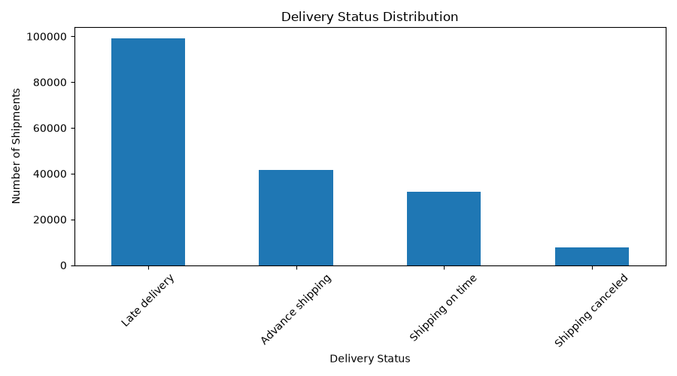
Figure 7. Delivery status KPI visualization
The results show a substantial gap between the proposed 90% on-time target and the observed on-time rate of approximately 42.72%. This indicates that delay management is a major area for improvement in the analyzed dataset.

8.1 Shipping Mode Comparison
Shipping Mode | Average actual shipping time
Same Day | 0.48 days
First Class | 2.00 days
Second Class | 3.99 days
Standard Class | 4.00 days
Same Day has the lowest average actual shipping time in the dataset, while Standard Class and Second Class have much higher averages. These differences support the use of transportation-mode-specific monitoring and planning.
Figure 8. Average shipping time by mode

8.2 Regional Distribution
Rank | Order Region | Records
1 | Central America | 28,341
2 | Western Europe | 27,109
3 | South America | 14,935
4 | Oceania | 10,148
5 | Northern Europe | 9,792
6 | Southeast Asia | 9,539
7 | Southern Europe | 9,431
8 | Caribbean | 8,318
9 | West of USA | 7,993
10 | South Asia | 7,731
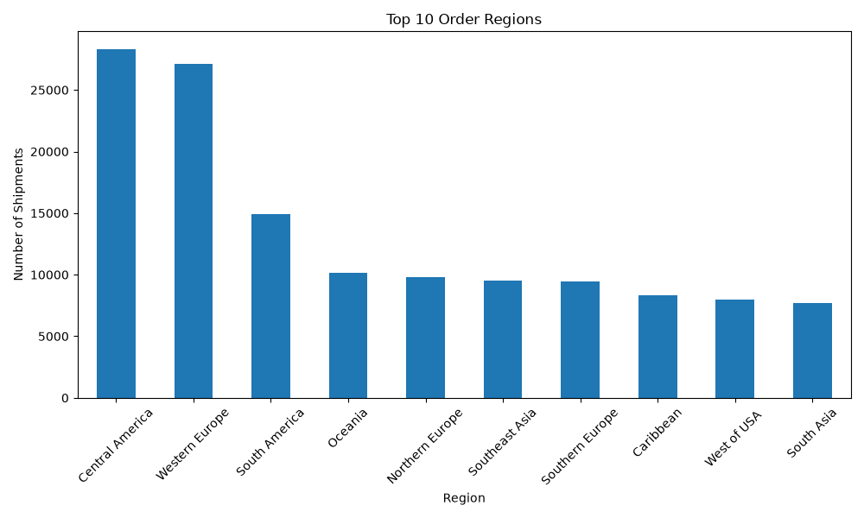
Figure 9. Top order regions by record count

9. Data Science Methodologies

9.1 Regression
Linear Regression was implemented to demonstrate delivery-time prediction. The target variable is Days for shipping (real). Predictors are Days for shipment (scheduled), Order Item Quantity, and Order Item Product Price. The dataset was split into 80% training and 20% testing using random_state=42.
Model metric | Result
Mean Absolute Error (MAE) | 1.130 days
R² score | 0.270
The model's MAE indicates an average absolute prediction error of about 1.13 days on the test set. The R² value of about 0.27 indicates that these three predictors explain a limited portion of variation in actual shipping time. Therefore, the model is useful as a baseline demonstration, but a stronger predictive system would require additional explanatory features.

9.2 Clustering
K-Means clustering was applied to four standardized variables: actual shipping days, scheduled shipping days, order item quantity, and order item product price. Three clusters were created using random_state=42 and n_init=10.
Cluster | Records
Cluster 0 | 58,611
Cluster 1 | 47,867
Cluster 2 | 74,041
The resulting shipment segments can be used as an operational starting point for differentiated monitoring. The cluster assignments were saved to 04_Analysis/shipment_clusters.csv.

9.3 Optimization Strategy
- Assign shipments to transportation modes appropriate for service requirements.
- Prioritize delayed or high-risk shipments for intervention.
- Allocate resources according to shipment volume and operational demand.
- Group similar shipments to improve planning and reduce unnecessary handling.
- Use predicted delivery time as an input for proactive planning.
- Monitor KPIs continuously and investigate regions or modes with poor performance.

10. Strategic Roadmap
- Data collection – obtain reliable shipment and delivery records.
- Data cleaning – validate missing values, duplicates, dates, and numeric fields.
- Exploratory analysis – understand distributions, delays, regions, and transportation modes.
- KPI analysis – monitor on-time performance, average time, delay, fulfillment, and cancellation.
- Predictive modeling – improve delivery-time prediction using relevant features.
- Shipment segmentation – identify operational groups using clustering.
- Optimization – use insights to improve resource allocation and transportation planning.
- Reporting – communicate findings through dashboards, charts, and recommendations.

11. Business Insights and Recommendations
- The observed on-time rate is 42.72%, substantially below the proposed 90% planning target; delivery delays should therefore be a primary management focus.
- Average actual shipping time (3.50 days) exceeds average scheduled time (2.93 days), indicating systematic schedule slippage in the analyzed records.
- Transportation modes show clear differences in average shipping time, supporting mode-specific service-level monitoring.
- Regional record volumes vary considerably, so resource planning should account for regional shipment concentration.
- The baseline regression model has limited explanatory power, suggesting that additional variables such as distance, region, market, status, and operational factors should be evaluated in future modeling.
- K-Means segmentation provides a practical framework for separating shipment groups and designing differentiated monitoring or service strategies.

12. Limitations
- The dataset does not provide a direct profit-margin calculation based on logistics cost.
- Promotion identifiers do not provide a complete numeric discount percentage for every transaction.
- Customer-level behavioral analysis is limited by the available identifiers and project scope.
- Inventory sell-through and campaign ROI cannot be measured without inventory and campaign data.
- The regression model is a baseline and uses only three predictors.
- Optimization is presented as a strategy framework rather than a mathematical optimization solver with a complete cost function and constraints.

13. Future Scope
- Add distance, weather, traffic, carrier, warehouse, and route-level features where available.
- Compare multiple regression models and tree-based models for improved delivery prediction.
- Develop a classification model to predict late-delivery risk.
- Build a Power BI dashboard for live KPI monitoring.
- Implement mathematical optimization for route and resource allocation using explicit cost and capacity constraints.
- Create an automated pipeline for periodic data refresh, model scoring, and KPI reporting.

14. Conclusion
This project demonstrates how Python and data science can be applied to logistics performance analysis. The cleaned dataset contains 180,519 records and provides sufficient information to measure delivery performance, compare shipping modes, examine regional patterns, and establish baseline predictive and segmentation models. The observed on-time rate of 42.72% and average delay of 0.57 days show a clear opportunity for operational improvement. Regression and K-Means clustering provide starting points for prediction and shipment segmentation, while the proposed optimization strategies translate analytical findings into practical logistics actions. Overall, the project establishes a structured, data-driven foundation for improving delivery performance and transportation resource planning.

15. References
- Kaggle – DataCo Smart Supply Chain Dataset.
- Python documentation – Python programming language.
- Pandas documentation – Data analysis and manipulation.
- Scikit-learn documentation – Machine learning in Python.
- Matplotlib documentation – Data visualization.
- Seaborn documentation – Statistical data visualization.

Appendix A – Python Code Illustrations
The project package contains the executable Python scripts used during the workflow, including phase5_data_cleaning.py, phase6_eda.py, phase7_kpi_analysis.py, phase8_data_science.py, and kpi_analysis_template.py. The main analytical workflow includes:
- Loading the raw logistics CSV with Pandas.
- Cleaning and preprocessing shipment fields.
- Deriving Delivery Delay and Delivery Performance.
- Generating EDA and KPI visualizations.
- Training Linear Regression and calculating MAE/R².
- Applying StandardScaler and KMeans for shipment clustering.
- Saving cluster results to 04_Analysis/shipment_clusters.csv.
Project folder structure and detailed phase documentation are retained in the accompanying VS Code project ZIP.

